Final cheksum -IP_SUMMED
LRO_F_NAPI ->packet should be passed upward with netif_recieve_skb()

get_skb_header/get_frag_header-->get tcp tcp & ip header

max_aggr---no. of packets to form ->One LRO
max-desc---no of LRO to process simultaneously

lro_array----lro _packet 1
------lro_packet 2
------lro_packet3

LRO

Yes No
lro_recieve_skb() netif_rx or
(Joins packets) netif_receive_skb()
calls get_skb_header(priv)

lro_flush_all ---occasional sending with No LRO
lro_flaush_packet--individual packet flushing

napi_poll -->call lro_flush_all ---->to send all packets to stack.

packets -skbuf -lro_receieve_skb
-page-lro_receive_frags

Hardware Descriptor Ring
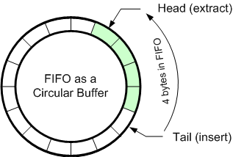

------------->

Memory

Hw descriptor ring points to skb buffer in memory.

SoftIRQ- NAPI
irq_register-MSI-X

Skbuff are doubly linked list

RX--->hw>>do_irq-->napi_scheduler/nterrupt->next_rx_-->poll(NAPI)-->netif_recieve_skb

TX-tcp_transmit_skb->ip_quue_xmit->dev_queue_xmit->Qdisk enquue->Qdisk_run->dev_hard_start_xmit

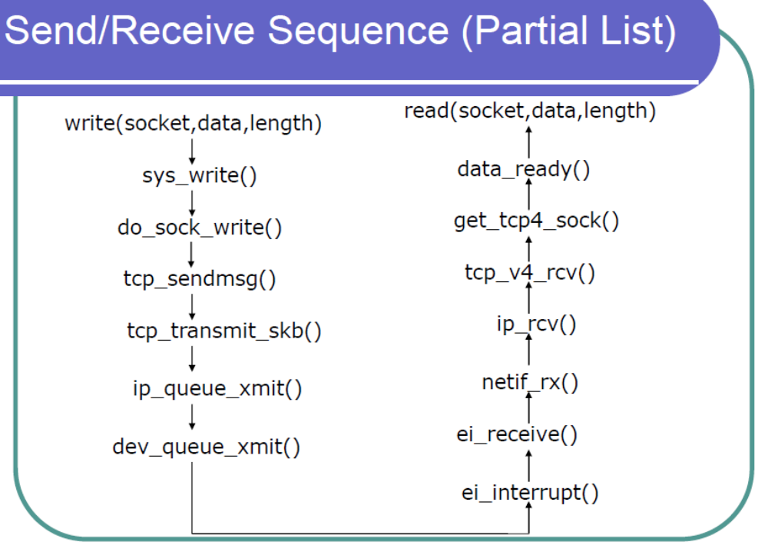

􀁺 write(socket,data,length)
􀁺 Copy data to kernel memory
􀁺 sys_write()
􀁺 Component of the Virtual File System
􀁺 Test conditions
􀁺 do_sock_write()
􀁺 Transfer parameters of write in message structure
􀁺 Verify that user area is readable by user process
􀁺 Extract pointer to INET socket structure sock
􀁺 Extract protocol operation – send operation
􀁺 tcp_sendmsg()
􀁺 Called with pointer to message structure and other
parameters (e.g. priority, out of band)
􀁺 Test for error conditions and connection to finish
􀁺 Allocate new segment to fit within single page
􀁺 Initialize IP header
􀁺 Initialize TCP header
􀁺 Copy data from process address space to the TCP
segment and calculate checksum
􀁺 tcp_transmit_skb()
􀁺 Fill in TCP headers and pass data to IP layer
􀁺 ip_queue_xmit()
􀁺 Add to the IP protocol header values that can now be
established (e.g. checksum for IP header)
􀁺 Slot packet into wait queue of packets ready for transfer
􀁺 dev queue xmit()
􀁺 Queue a buffer for transmission to a network device
􀁺 Function can be called from an interrupt

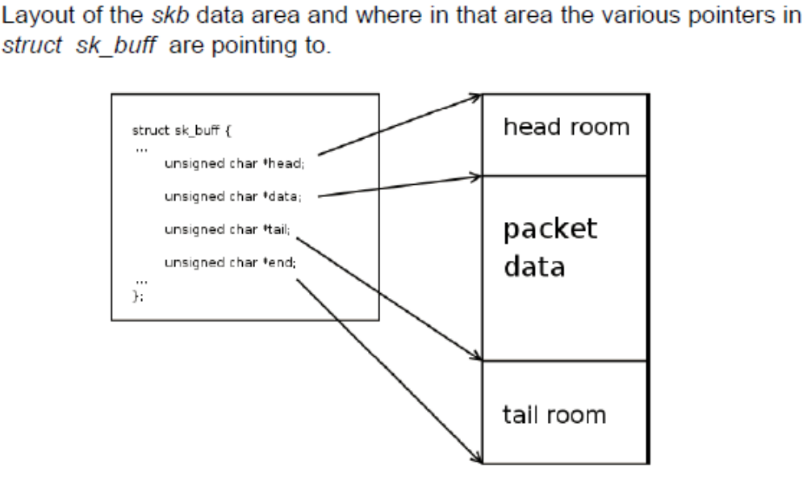

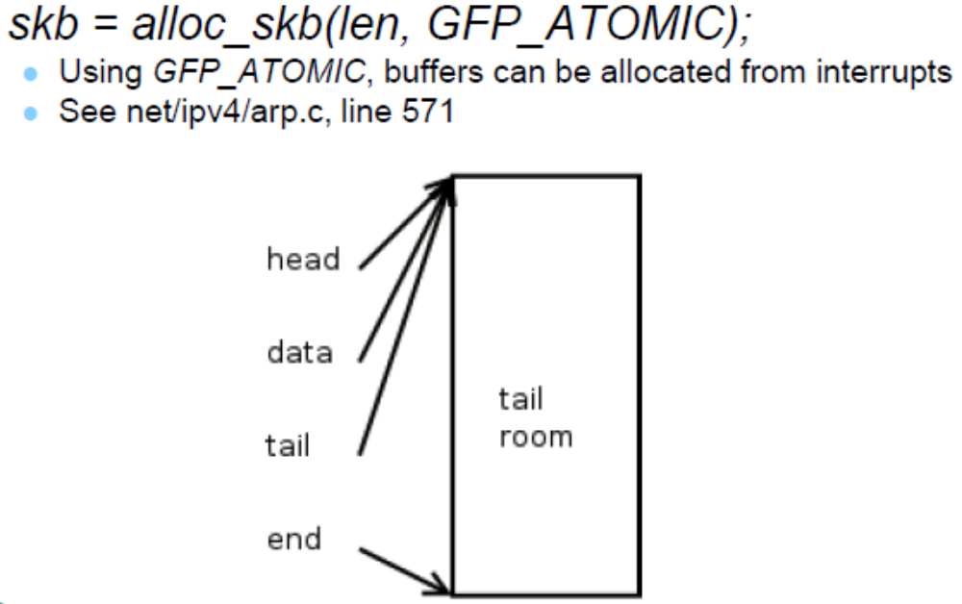

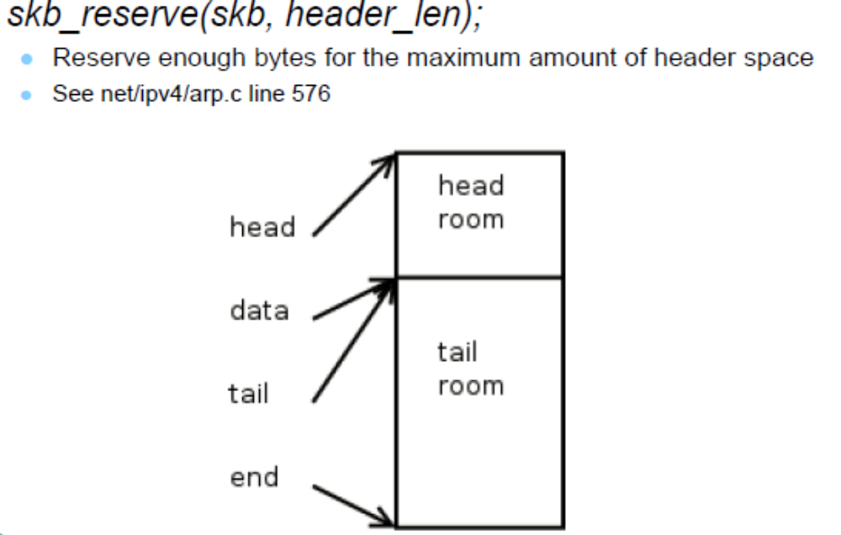

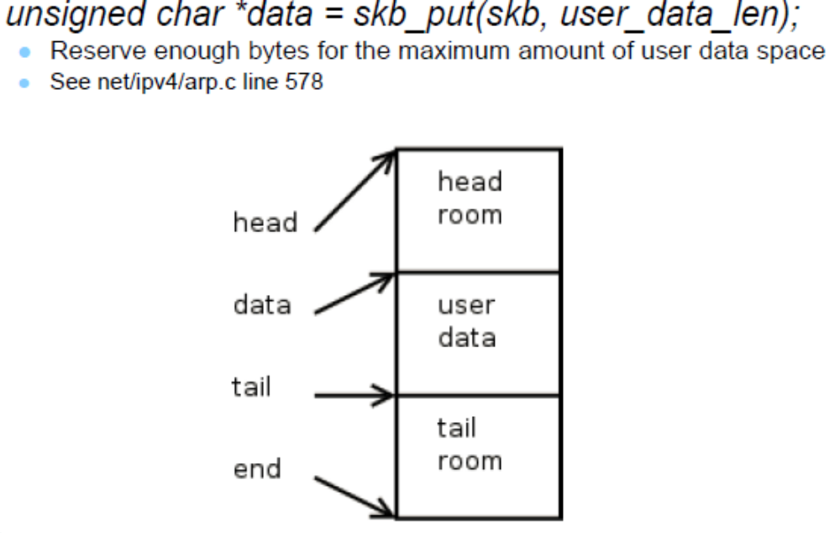
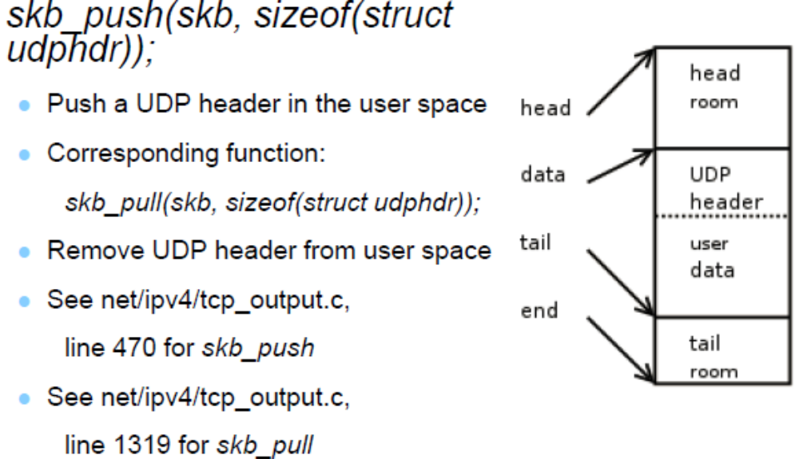

Checksum Offloading
The Ethernet controller provides the ability to offload the IP, TCP, and UDP checksum requirements
from the software device driver. For common frame types, the hardware automatically
calculates, inserts, and checks the appropriate checksum values normally handled by software.
For transmits, every Ethernet packet might have two checksums calculated and inserted by the
Ethernet controller. Typically, these would be the IP checksum, and either the TCP or UDP
checksum. The software device driver specifies which portions of the packet are included in the
checksum calculations, and where the calculated values are inserted via descriptors (refer to
Section 3.3.5 for details).
For receives, the hardware recognizes the packet type and performs the checksum calculations and
error checking automatically. Checksum and error information is provided to software through the
receive descriptors (refer to Section 3.2.9 for details).

IPv6 packets do not have IP checksums.(TCP Checksum is present)

TCP Segmentation
Hardware TCP Segmentation is one of the off-loading options of most modern TCP/IP stacks. This
is often referred to as “Large Send” offloading. This feature enables the TCP/IP stack to pass to the
Ethernet controller software driver a message to be transmitted that is bigger than the Maximum
Transmission Unit (MTU) of the medium. It is then the responsibility of the software driver and
hardware to carve the TCP message into MTU size frames that have appropriate layer 2 (Ethernet),
3 (IP), and 4 (TCP) headers. These headers must include sequence number, checksum fields,
options and flag values as required. Note that some of these values (such as the checksum values)
are unique for each packet of the TCP message, and other fields such as the source IP address is
constant for all packets associated with the TCP message.
The offloading of these processes from the software driver to the Ethernet controller saves
significant CPU cycles. The software driver shares the additional tasks to support these options
with the Ethernet controller.

Packet Filtering IN NICs
The following filter modes are supported:
• Exact Unicast/Multicast — The destination address must exactly match one of 16 stored
addresses. These addresses can be unicast or multicast.
• Promiscuous Unicast — Receive all unicasts.
• Multicast — The upper bits of the incoming packet’s destination address index a bit vector
that indicates whether to accept the packet; if the bit in the vector is one, accept the packet,
otherwise, reject it. The controller provides a 4096 bit vector. Software provides four choices
of which bits are used for indexing. These are [47:36], [46:35], [45:34], or [43:32] of the
internally stored representation of the destination address.
• Promiscuous Multicast — Receive all multicast packets.
• VLAN — Receive all VLAN1 packets that are for this station and have the appropriate bit set
in the VLAN filter table. A detailed discussion and explanation of VLAN packet filtering is
contained in

UDP Fragmentation
UDP (unlike TCP) is not a “reliable protocol”, and fragmentation is not supported at the UDP
level. UDP messages that are larger than the MTU size of the given network medium are normally
fragmented at the IP layer. This is different from TCP, where large TCP messages can be
fragmented at either the IP or TCP layers depending on the software implementation. The Ethernet
controller has the ability to segment UDP traffic (in addition to TCP traffic).

TCP Segmentation Driver changes
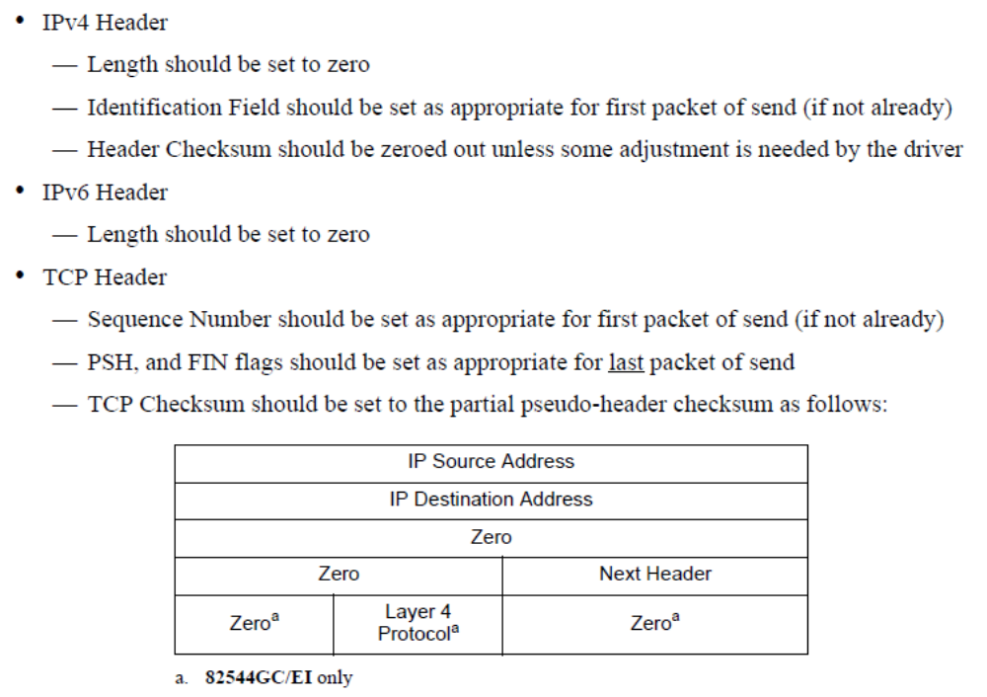

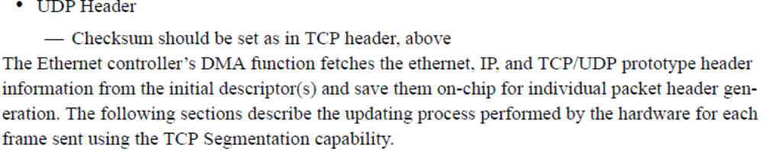

Message Signaled Interrupts1
Message Signaled Interrupt (MSI) capability is optional for PCI 2.2 or 2.3, but required for PCI-X.
When Message Signaled Interrupts are enabled, instead of asserting an interrupt pin, the Ethernet
controller generates an interrupt using a memory write command. The address and most of the data
of the command are determined by the system and programmed in configuration registers. This
permits the system to program a different message for each function so it can speed up interrupt
delivery.
To enable Message Signaled Interrupts, the system software writes to the “MSI Enable” bit in the
MSI “Message Control” register. When Message Signaled Interrupts are enabled, the Ethernet
controller no longer asserts its INTA# pin to signal interrupts.

• net device
• include/linux/netdevice.h
• sk buff
• include/linux/skbuff.h

net device (include/linux/netdevice.h)
• unsigned int mtu
• unsigned int flags
• unsigned char dev addr[MAX ADDR LEN]
• int promiscuity

net_device represents a network interface card

unsigned int mtu – Maximum Transmission Unit: the maximum size of frame the device can handle.

unsigned int flags (
which you see or set using ifconfig utility): for example, RUNNING or NOARP.

● unsigned char dev_addr[MAX_ADDR_LEN] : the MAC address of the device (6 bytes).

● int (*hard_start_xmit)(struct sk_buff *skb, struct net_device *dev);
– a pointer to the device transmit method.

● int promiscuity; (a counter of the times a NIC is told to set to work in promiscuous mode; used to enable more than one sniffing client.)

sk buff (include/linux/skbuff.h)
• struct sk buff *next;
• struct sk buff *prev;
• ktime t tstamp;
• struct net device *dev;
• unsigned int len;
• unsigned int data len;
• u16 mac len;
• u8 pkt type;
• be16 protocol;
• sk buff data t transport header; (old h)
• sk buff data t network header; (old nh)
• sk buff data t mac header; (old mac)

sk_buff includes 3 unions; each corresponds to a kernel network layer:
● transport_header (previously called h) – for layer 4, the transport layer (can include tcp header or udp header or icmp header, and more)
● network_header – (previously called nh) for layer 3, the network layer (can include ip header or ipv6 header or arp header).
● mac_header – (previously called mac) for layer 2, the link layer.● skb_network_header(skb), skb_transport_header(skb) and skb_mac_header(skb) return pointer to the header.

Important sk_buff rountines
• alloc skb();
• dev alloc skb();
• kfree skb();
• dev kfree skb();
• skb clone();
• skb network header(skb);
• skb transport header(skb);
• skb mac header(skb);

ingress flow
• When working in interrupt driven model, the nic registers an
interrupt handler;
• This interrupt handler will be called when a frame is received;
• Typically in the handler, we allocate sk buff by calling
dev alloc skb();
• Copies data from nic’s buffer to this struct just created;
• nic call generic reception routine netif rx();
• netif rx() put frame in per cpu queue;
• if queue is full, drop!
• net rx action() decision based on skb->protocol;
• This function basically dequeues the frame and delivery a copy
for every protocol handler;
• ptype all and ptype base queues

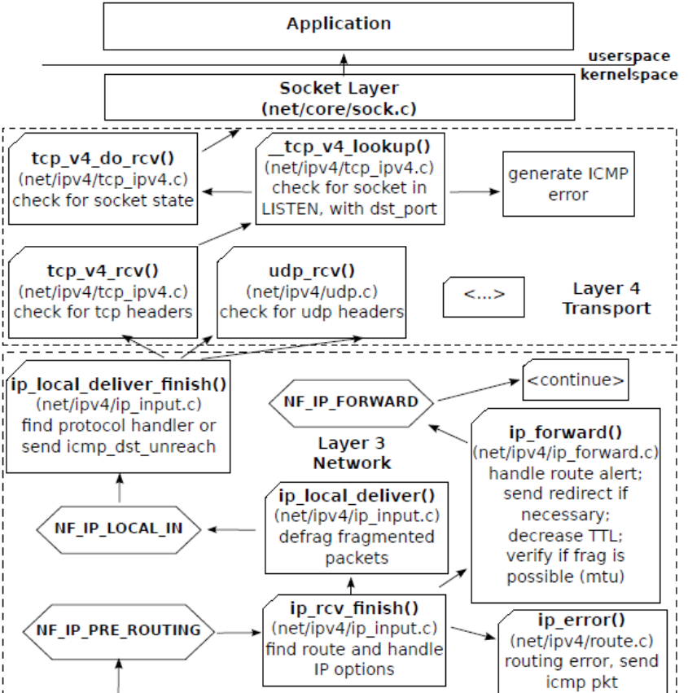

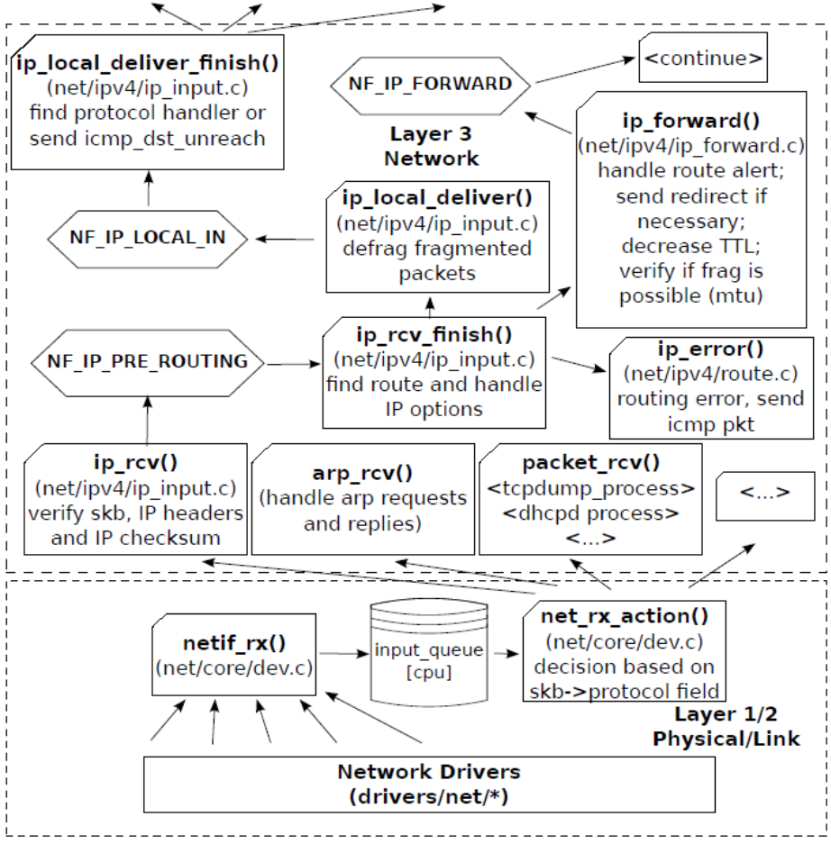

Netfilter
• iptables = userspace;
• netfilter = kernelspace;
• Netfilter is merely a series of hooks in various points in a
protocol stack;

Packet capture inside kernel

#netdevice.h
#skbuff.h
#ip.h

1 struct packet type my proto;
2
3 int my packet rcv(struct sk buff _skb, struct net device _dev,
4 struct packet type _pt, struct net device _orig dev) {
5
6 printk(KERN ERR ”+ 1!\n”);
7
8 kfree skb(skb);
9 return 0;
10 }
11
12 static int hello init(void) {
13 printk(”<1> Hello world!\n”);
14
15 my proto.type = htons(ETH P ALL);
16 my proto.dev = NULL;
17 my proto.func = my packet rcv;
18
19 dev add pack(&my proto);
20 return 0;
21 }
22
23 static void hello exit(void) {
24 dev remove pack(&my proto);
25 printk(”<1> Bye, cruel world\n”);
26 }
27 module init(hello init);
28 module exit(hello exit);
1 int my packet rcv(struct sk buff _skb, struct net device _dev, struct packet type _pt, struct net device
_orig dev)
2 {
3 switch (skb−>pkt type) {
4 case PACKET HOST:
5 printk(”PACKET HOST − ”);
6 break;
7 case PACKET BROADCAST:
8 printk(”PACKET BROADCAST − ”);
9 break;
10 case PACKET MULTICAST:
11 printk(”PACKET MULTICAST − ”);
12 break;
13 case PACKET OTHERHOST:
14 printk(”PACKET OTHERHOST − ”);
15 break;
16 case PACKET OUTGOING:
17 printk(”PACKET OUTGOING − ”);
18 break;
19 case PACKET LOOPBACK:
20 printk(”PACKET LOOPBACK − ”);
21 break;
22 case PACKET FASTROUTE:
23 printk(”PACKET FASTROUTE − ”);
24 break;
25 }
26 printk(”%s 0x%.4X 0x%.4X \n”, skb−>dev−>name, ntohs(skb−>protocol), ip hdr(skb)−>protocol)
27
28 kfree skb(skb);
29 return 0;
30 }

Coalesced Interrupts/IRQ mitigation
The interrupt-handling costs for that high IRQ
rate imposes a significant overhead to the CPU and can in the extreme case lead to a
live-lock at the receiving side (Zec et al. , 2002). Therefore, at a certain threshold the CPU
is saturated with handling interrupts

One counter-measure can be to coalesce multiple
interrupts. There are two distinct flavors of this principle:
1.generic IRQ coalescing can be realized completely in software,

2 . hardware supported IRQ coalescing requires timers in the NIC.

TCP Segmentation Offloading
it relocates the interface between TCP stack and NIC. With TSO, the NIC is fed
with data buffers bigger than the MTU and control information instead of IP packets. The
effort to segment the data into packets is left to then NIC. Therefore, the CPU is saved
from the segmentation effort and at the the same time allowed to feed the NIC with
bigger data chunks.

TSO is especially useful for virtual networks
between VMs, because the device emulation can transmit the bigger data chunks provided
by the NIC driver directly without segmentation, which reduces overhead in the device
model.

Jumbo Frames
One of the most simplistic approaches to reduce the overhead per packet is to increase
the packet size (Dykstra, 1999). For compliance to the ethernet IEEE 802.3 standard the
packet size is limited to 1500 bytes. Jumbo frames extend this limitation to 9000 byte.

DMA vs DVMA

the proper Some platforms, such as SPARC systems, support what is called Direct Virtual Memory Access
(DVMA). On these platforms, the device is provided with a virtual address by the system in
order to perform the transfer. In this case, the underlying platform provides an IOMMU, which
translates accesses to these virtual addresses into physical addresses.
On platforms that support DMA, the system provides the device with a physical address in order to perform transfers. In this case, the transfer of a DMA object can actually consist of a number of physically discontiguous transfers. An example is when an application transfers a buffer that spans several contiguous virtual pages that map to physically discontiguous pages. To deal with the discontiguous memory, devices for these platforms usually have some kind of scatter-gather DMA capability. Typically, x86 systems provide physical addresses for direct memory transfers.
On platforms that support DVMA, the system provides the device with a virtual address to perform transfers. In this case, memory management units (MMU) provided by the underlying platform translate device accesses to these virtual addresses into the proper physical addresses. The device transfers to and from a contiguous virtual image that can be mapped to discontiguous physical pages. Devices that operate in these platforms do not need scatter-gather DMA capability. Typically, SPARC platforms provide virtual addresses for direct memory transfers.

NAPI in Solaris in Solaris, polling is built into the kernel (no need to build drivers in any special way).

Allocating a SKB
- Function dev_alloc_skb() allows to allocate an SKB
- Can be called from an interrupt handler.Usually the case on reception.
- On Ethernet, the size allocated is usually the length of the packet
+ 2, so that the IP header is wordaligned (the Ethernet header is 14 bytes)

skb = dev_alloc_skb(length + NET_IP_ALIGN);

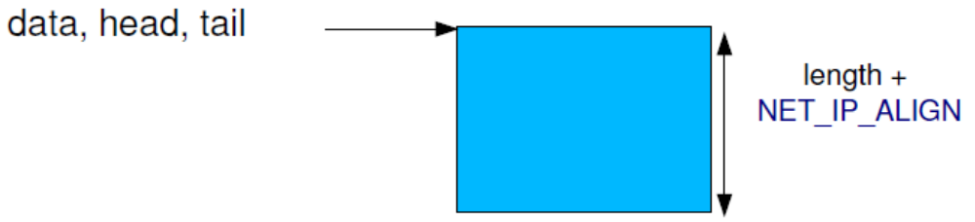

- Need to skip NET_IP_ALIGN bytes at the beginning of the SKB
- Done with skb_reserve()

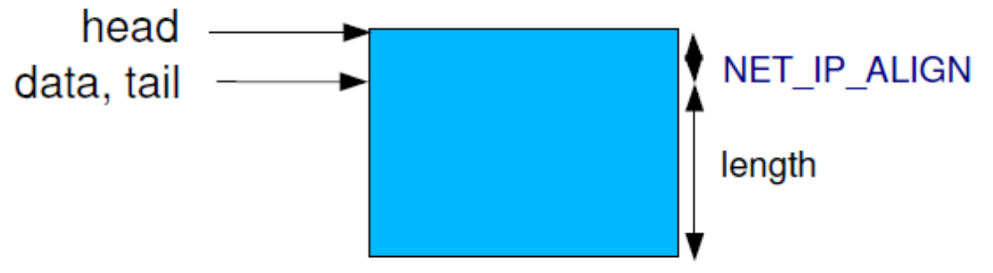

Copy the received data
The packet payload must be copied from the DMA buffer to the SKB, using
static inline void skb_copy_to_linear_data(struct sk_buff *skb, const void *from, const unsigned int len);
static inline void skb_copy_to_linear_data_offset(struct sk_buff *skb, const int offset, const void *from, const
unsigned int len);

skb_copy_to_linear_data(skb, dmabuffer, length);

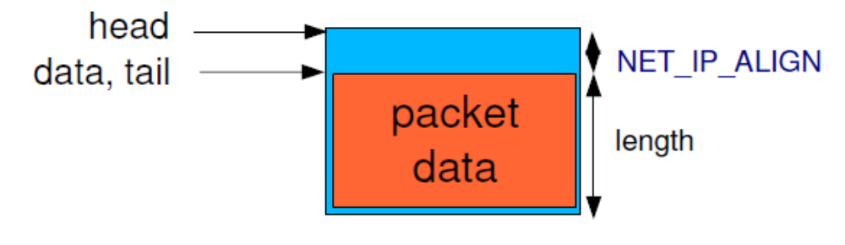

skb_put() is used to update the SKB pointers after copying the payload.
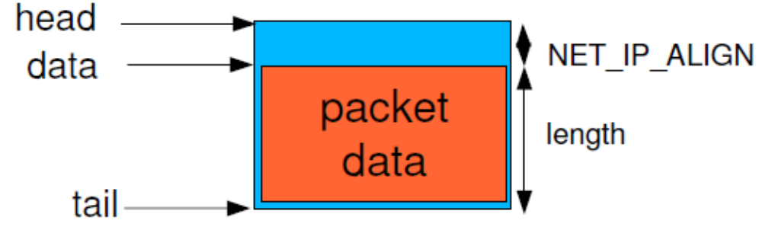

struct net_device
- This structure represents a single network interface.
- Allocation takes place with alloc_etherdev()
- The size of private data must be passed as argument. The pointer to these private data can be read in
net_device>priv
- alloc_etherdev() is a specialization of alloc_netdev() for Ethernet interfaces
- Registration with register_netdev()
- Unregistration with unregister_netdev()
- Liberation with free_netdev()

The methods of a network interface. The most important ones:
- ndo_open(), called when the network interface is up'ed
- ndo_close(), called when the network interface is down'ed
- ndo_start_xmit(), to start the transmission of a packet
And others:
- ndo_get_stats(), to get statistics
- ndo_do_ioctl(), to implement device specific operations
- ndo_set_rx_mode(), to select promiscuous, multicast, etc.
- ndo_set_mac_address(), to set the MAC address
- ndo_set_multicast_list(), to set multicast filters

Set the netdev_ops field in the struct net_device structure to point to the struct net_device_ops structure.
netif_start_queue()
Tells the kernel that the driver is ready to send packets
netif_stop_queue()
Tells the kernel to stop sending packets. Useful at driver cleanup of course, but also when all transmission buffers are full.
netif_queue_stopped()
Tells whether the queue is currently stopped or not ?
netif_wake_queue()
Wakeup a queue after a netif_stop_queue().The kernel will resume sending packets

Transmission
- The driver implements the ndo_start_xmit() operation
- The kernel calls this operation with a SKB as argument
- The driver sets up DMA buffers and other hardware dependent mechanisms and starts the transmission
- Depending on the number of free DMA buffers available, the driver can also stop the queue with netif_stop_queue()
- When the packet has been sent, an interrupt is raised. The driver is responsible for
  - Acknowledging the interrupt
  - Freeing the used DMA buffers
  - Freeing the SKB with dev_kfree_skb_irq()
  - If the queue was stopped, start it again
- Returns NETDEV_TX_OK or NETDEV_TX_BUSY.

Reception (Without NAPI)

- Reception is notified by an interrupt. The interrupt handler should
- Allocate an SKB with dev_alloc_skb()
- Reserve the 2 bytes offset with skb_reserve()
- Copy the packet data from the DMA buffers to the SKB
- skb_copy_to_linear_data() or
- skb_copy_to_linear_data_offset()
- Update the SKB pointers with skb_put()
- Update the skb>protocol field with eth_type_trans (skb, netdevice)
- Give the SKB to the kernel network stack with netif_rx(skb)

Reception (With NAPI)

- The original mode is nice and simple, but when the network traffic ishigh, the interrupt rate is high. The NAPI mode allows to switch to polled mode when the interrupt rate is too high.
- In the network interface private structure, add a struct napi_struct
- At driver initialization, register the NAPI poll operation:
netif_napi_add(dev, &bp>napi, macb_poll, 64);
- dev is the network interface
- &bp>napi is the struct napi_struct
- macb_poll is the NAPI poll operation
64 is the «weight» that represents the importance of the network
interface. It limits the number of packets each interface can feed to the
networking core in each polling cycle. If this quota is not met, the driver
will return back to interrupt mode. Don't send this quota to a value
greater than the number of packets the interface can store.
- In the interrupt handler, when a packet has been received:
if (napi_schedule_prep(&bp>napi)) {
/* Disable reception interrupts */
__napi_schedule(& bp>napi);
}
- The kernel will call our poll() operation regularly.
- The poll() operation has the following prototype static int macb_poll(struct napi_struct *napi, int budget)
It must receive at most budget packets and push them to the network stack using netif_receive_skb().
If less than budget packets have been received, switch back to interrupt mode using
napi_complete(& bp>napi) and reenable interrupts.
- Must return the number of packets received

MAC & PHY

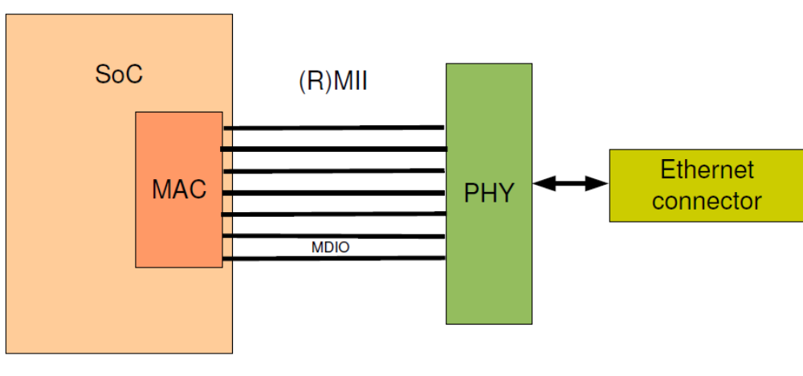

The MAC and the PHY are connected using a MII or RMII interface
MII = Media Independent Interface
RMII = Reduced Media Independent Interface
This interface contains two wires used for the MDIO bus (Management Data Input/Output)

MDIO driver ( part of ethernet driver) , needs to communicate with the PHY to get information about the link (up, down, speed, full or half duplex) and configure the MAC accordingly.

Ethtool

ethtool is a userspace tool that allows to query lowlevel information from an Ethernet interface and to modify its
configuration
On the kernel side, at the driver level, a struct ethtool_ops structure can be declared and connected to the struct
net_device using the ethtool_ops field.

List of operations: get_settings(), set_settings(), get_drvinfo(), get_wol(), set_wol(), get_link(),
get_eeprom(), set_eeprom(), get_tso(), set_tso(), get_flags(), set_flags(), etc.

Some of these operations can be implemented using the PHY interface (phy_ethtool_gset(), phy_ethtool_sset()) or using generic operations (ethtool_op_get_link() for example).

ethtool basic example???

NAPI

NAPI combines interrupt and polling mechanisms
• Interrupts are disabled after first one
• Then ring is polled periodically and packets are pulled as necessary
• When no new packets, interrupts restarted

Network Device Structure
struct net_device {
char *name;
unsigned long base_addr;
// Base address of Memory adress space used by Device
unsigned char addr_len; // MAC address length
unsigned char dev_addr[MAX_ADDR_LEN]; // Ethernet address or MAC address
unsigned char broadcast[MAX_ADDR_LEN];
unsigned short hard_header_len; // Hardware Header Length
unsigned char irq; // Interrupt Number
int (*open) (struct net_device *dev); // Function which opens the device.
int (*stop) (struct net_device *dev); // Function to Close the Device
int (*hard_start_xmit) (struct sk_buff *skb, struct net_device *dev);
struct net_device_stats* (*get_stats)(struct net_device *dev);
void *priv; /* Holds the data private to the Device Driver.
* In our case will be used to keep data related to PCI device*/
};

Private Structure
struct rtl8139_private {
struct pci_dev *pci_dev; /* PCI device */
void *mmio_addr; /* memory mapped IO addr */
unsigned long regs_len; /* length of IO or MMIO region */
}
1. Structure to hold the data private to our device
2. It will be pointed by structure net_device member “priv”.

Initializing network driver

static int rtl8139_init (struct pci_dev *pdev, struct net_device **dev_out )
{
struct net_device *dev;
struct rtl8139_private *tp;
/* alloc_etherdev allocates memory for dev and dev->priv.
* dev->priv shall have sizeof(struct rtl8139_private) memory allocated.
*/
dev = alloc_etherdev(sizeof(struct rtl8139_private));
if(!dev) {
printk("Could not allocate etherdev\n");
return -1;
}t
p = dev->priv;
tp->pci_dev = pdev;
*dev_out = dev;
return 0;
}

Skb - Add the data then header as it passes through the stack.

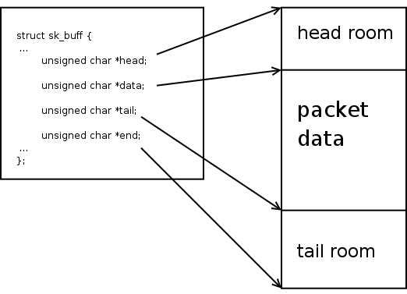
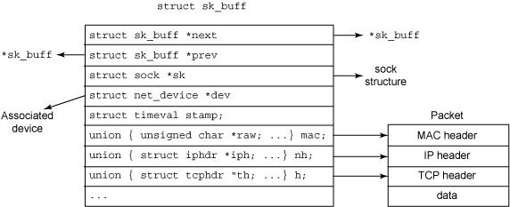

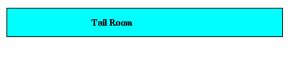
Figure 1: After alloc_skb
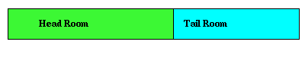
Figure 2: After skb_reserve
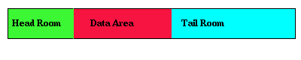
Figure 3: An sk_buff containing data

The sk_buff has two places where it can store the next fragmentation data:
skb_shinfo(head)->frag_list
skb_shinfo(head)->frags[]

frags[]

When your device supports scatter-gather I/O, and you want it to do the combining of data etc.. you can populate frags[] structure starting with the 2nd fragment till nth fragment. The first fragment is always specified by the data and tail pointers. Rest of the fragments are filled in the frags[] structure
in SG first buffer wil have the tail room head room and all the headers the subsequent buffers wont have these details hence they call them skb_shared _info

frag_list

This is the list of IP fragments. This will be filled during ip_push_pending_frames. Say your sk_buffs are in this arrangement

sk_buff0->next = sk_buff1
sk_buff1->next = sk_buff2
...
sk_buffn-1->next = sk_buffn
After ip_push_pending_frames is called

sk_buff0->frag_list = sk_buff1
sk_buff1->next = sk_buff2
...
sk_buffn-1->next = sk_buffn
Simply put

frags[] are for scatter-gather i/o buffers

frag_list is for ip fragments

>Fraglist stores link list of sk_buff
>All sk_buf contains same IP Header only different is
ID Field
fragmet offset
checksum
>Used for IP Fragmentation

The frags is the place where additional data pages are stored. Each frag_list corresponds to an IP fragmentation (the TCP is fragmented at IP layer).

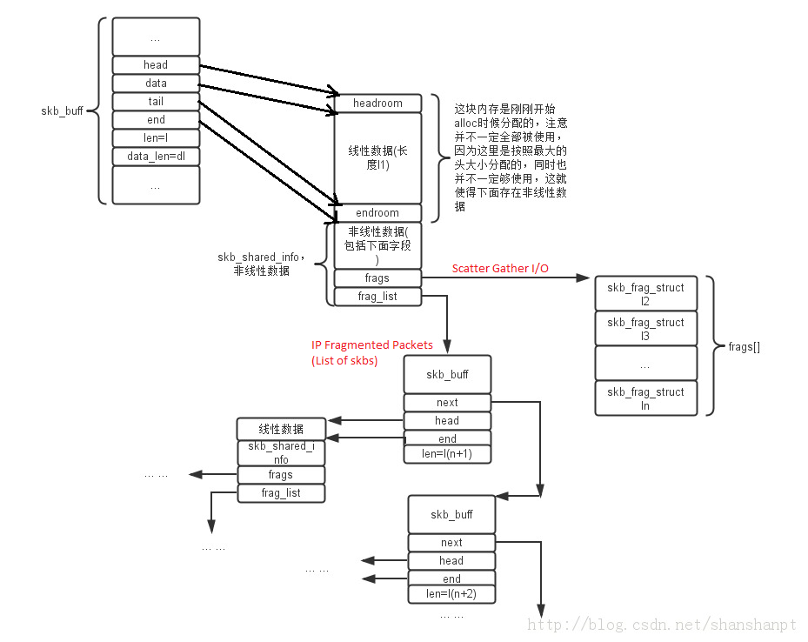

skb_shared_info -->
1.Frags[]
2.Frag_list

